TECHNICAL REFERENCE GUIDE
SQL Server On-Premises
to
Azure SQL Managed Instance
Online Migration via Azure Database Migration Service
14 Banking Databases | SSIS Compatibility Assessment | SSISDB on SQL MI
Node5 SQL Server 2019 → usha-sqlmi-poc (West US 2, Free Tier)

OrgSpire Inc. | Database Administration Team
Version 1.0 | April 2026
Author: Usha Kale — Senior Cloud DBA / Azure Data Engineer

1. Migration Overview & Environment
This document provides a complete technical walkthrough of the online migration of 14 SQL Server 2019 banking databases from on-premises (Node5, VirtualBox lab) to Azure SQL Managed Instance using Azure Database Migration Service (DMS). The migration uses continuous log replay (online mode) achieving near-zero downtime, with cutover executed after all 14 databases reached Ready for cutover status.

This POC demonstrates production-grade cloud migration patterns applicable to enterprise banking environments with PCI DSS, SOX, and FFIEC compliance requirements.

1.1 Environment Summary
Property | Value
Source Server | Node5 — SQL Server 2019 (15.0.4430.1), VirtualBox Lab
Source Instance | Node5_MSSQLSERVER
Databases Migrated | 14 banking databases (0.02 GB – 0.33 GB each)
Target | usha-sqlmi-poc — Azure SQL Managed Instance
Target Region | West US 2 (Free tier available in this region only)
Target Tier | General Purpose, 4 vCores — Free Tier, 12 months
Public Endpoint | usha-sqlmi-poc.public.0f3157bbdbf7.database.windows.net,3342
Private Endpoint | usha-sqlmi-poc.0f3157bbdbf7.database.windows.net,1433
Migration Service | usha-dms-poc — Azure Database Migration Service (West US 2)
Migration Mode | Online — continuous log replay, cutover on demand
Backup Storage | ushamigrationpoc — container: sqlbackups — 14 subfolders
Admin Login | ssisadmin (SQL Auth + Microsoft Entra both enabled)
TDE | Enabled — service-managed key
Defender for SQL | Enabled — 30-day free trial
Resource Group | Usha_SQLMI_POC
Migration Started | April 7, 2026 at 8:13 PM Pacific Time
Cutover Completed | April 7, 2026 at 8:42 PM Pacific Time
Total Duration | ~29 minutes end-to-end per database

1.2 All 14 Databases Migrated
Database | Size (GB) | Recovery Model | state_desc | Migration Status
AcquiredBanks_OnPrem_POC | 0.20 | FULL | ONLINE | ✅ Succeeded
AutoLoans_DB | 0.02 | FULL | ONLINE | ✅ Succeeded
BankingDW_DB | 0.33 | FULL | ONLINE | ✅ Succeeded
Compliance_DB | 0.02 | FULL | ONLINE | ✅ Succeeded
CoreBank_OnPrem_POC | 0.20 | FULL | ONLINE | ✅ Succeeded
CreditCards_DB | 0.02 | FULL | ONLINE | ✅ Succeeded
FraudDetection_DB | 0.02 | FULL | ONLINE | ✅ Succeeded
HumanResources_DB | 0.02 | FULL | ONLINE | ✅ Succeeded
Insurance_DB | 0.02 | FULL | ONLINE | ✅ Succeeded
LoanProcessing_Staging | 0.02 | FULL | ONLINE | ✅ Succeeded
Mortgage_DB | 0.02 | FULL | ONLINE | ✅ Succeeded
RetailBanking_DB | 0.02 | FULL | ONLINE | ✅ Succeeded
TradeFinance_DB | 0.02 | FULL | ONLINE | ✅ Succeeded
WealthMgmt_DB | 0.02 | FULL | ONLINE | ✅ Succeeded

2. Pre-Migration Assessment
Before executing the migration, a compatibility assessment was performed using the Az.DataMigration PowerShell module — the successor to the retired Database Migration Assistant (DMA). The assessment identifies feature blockers, compatibility issues, and SKU recommendations for the target SQL MI.

NOTE | DMA (Database Migration Assistant) was retired in July 2025. The current toolchain uses the Az.DataMigration PowerShell module: Get-AzDataMigrationAssessment and Get-AzDataMigrationSkuRecommendation. Requires .NET 8.0.17.

2.1 Az.DataMigration PowerShell Assessment
# Install Az.DataMigration module
Install-Module -Name Az.DataMigration -Force

# Authenticate to Azure
Connect-AzAccount

# Run assessment against Node5 SQL Server instance
Get-AzDataMigrationAssessment `
-ConnectionString 'Data Source=Node5;Initial Catalog=master;Integrated Security=True' `
-OutputFolder 'C:\DMAOutput' `
-Overwrite

# Get SKU recommendation for target sizing
Get-AzDataMigrationSkuRecommendation `
-PerfDataFolder 'C:\DMAOutput' `
-TargetPlatform AzureSqlManagedInstance `
-OutputFolder 'C:\DMAOutput'

[ SCREENSHOT ]
Az.DataMigration PowerShell — assessment output showing compatibility results for all 14 databases

[ SCREENSHOT ]
Az.DataMigration PowerShell — SKU recommendation output confirming General Purpose 4 vCores

2.2 SSIS Stress Test — Compatibility Assessment
A dedicated SSIS stress test suite (MigrationStressTest) was built and executed on Node5 to validate which SSIS package patterns are supported on Azure SQL MI and which require ADF modernization. Five packages were designed to test the most common SSIS patterns used in banking ETL environments.

SSIS Stress Test Results
Package | Purpose | On-Prem | SQL MI | Action Required
PKG_04_CrossDatabase | Cross-DB extract — 632,000 rows | ✅ Passing | ✅ Supported | Deploy as-is to SSISDB on SQL MI
PKG_07_CLR | CLR assembly execution stress test | ✅ Passing | ✅ Supported (SAFE) | Deploy as-is to SSISDB on SQL MI
PKG_01_LinkedServer | Linked server to NODE1 — sys.databases extract | ✅ Passing | ❌ Blocked | Rewrite: ADF Copy Activity with two Linked Services
PKG_03_XpCmdShell | OS-level commands via xp_cmdshell | ✅ Passing | ❌ Blocked | Rewrite: ADF Web Activity + Azure Function
PKG_06_MSDTC | Distributed transaction across Node5 and Node1 | ⚠ Lab limit | ❌ Blocked | Rewrite: ADF pipeline with compensating transactions

[ SCREENSHOT ]
SSIS package execution results on Node5 — all 5 packages showing on-premises pass/fail status

[ SCREENSHOT ]
Visual Studio — MigrationStressTest SSIS project — package list showing PKG_01 through PKG_07

NOTE | SQL MI does not support linked servers to on-premises SQL Server, xp_cmdshell, or MSDTC. PKG_04 and PKG_07 are safe to deploy directly to SSISDB. The three blocked packages require ADF modernization.

PKG_01 — Linked Server Fix Applied On-Premises
PKG_01 initially failed due to a sysname parameter type mismatch. Fix applied before migration:

-- Original call (fails: SQLNCLI11 sysname type error)
EXEC sp_testlinkedserver 'NODE1'

-- Fixed: N prefix forces Unicode sysname parameter resolution
EXEC sp_testlinkedserver N'NODE1'

3. Backup to URL — 14 Databases to Azure Blob Storage
Before DMS can perform an online migration, full database backups must be present in Azure Blob Storage organized in per-database subfolders. DMS reads these backups to initialize the restore on SQL MI, then applies subsequent transaction log backups continuously until cutover is executed.

CRITICAL | CRITICAL: DMS requires each database backup in its own named subfolder. Structure: sqlbackups/DatabaseName/DatabaseName_FULL.bak. A flat container causes the DMS folder dropdown to appear empty and migration will not start.

3.1 Storage Account Configuration
Property | Value
Storage Account | ushamigrationpoc (West US 2)
Container | sqlbackups
Folder Structure | 14 subfolders — one per database
Access Required | Storage Blob Data Reader on SQL MI managed identity AND your Azure account
Redundancy | Locally-redundant storage (LRS)
Access Tier | Cool (default) — sufficient for migration staging

[ SCREENSHOT ]
Azure Portal — ushamigrationpoc storage account — sqlbackups container showing 14 database subfolders

3.2 Backup T-SQL — Node5 SSMS
Run the following in SSMS on Node5. The SAS credential is required. Do NOT use WITH CREDENTIAL syntax — SQL Server auto-matches the URL to the credential by prefix.

-- Step 1: Create SAS credential on Node5 (run once)
CREATE CREDENTIAL [https://ushamigrationpoc.blob.core.windows.net/sqlbackups]
WITH IDENTITY = 'SHARED ACCESS SIGNATURE',
SECRET = '<SAS_TOKEN_WITHOUT_LEADING_QUESTION_MARK>';

-- Step 2: Backup each database to its own subfolder
-- Template — repeat for all 14 databases:
BACKUP DATABASE [BankingDW_DB]
TO URL = 'https://ushamigrationpoc.blob.core.windows.net/sqlbackups/BankingDW_DB/BankingDW_DB_FULL.bak'
WITH COMPRESSION, STATS = 10, CHECKSUM;

BACKUP DATABASE [CoreBank_OnPrem_POC]
TO URL = 'https://ushamigrationpoc.blob.core.windows.net/sqlbackups/CoreBank_OnPrem_POC/CoreBank_OnPrem_POC_FULL.bak'
WITH COMPRESSION, STATS = 10, CHECKSUM;

-- Continue pattern for remaining 12 databases...

-- Verify all backups present in blob storage:
-- Azure Portal -> ushamigrationpoc -> Containers -> sqlbackups
-- Confirm 14 subfolders each containing one .bak file

NOTE | Do NOT include WITH CREDENTIAL in the BACKUP TO URL statement. This causes a credential not found error. SQL Server 2012 SP1 CU2+ automatically resolves the credential by matching the URL prefix to the stored credential name.

[ SCREENSHOT ]
SSMS — BACKUP TO URL execution output showing STATS progress for all 14 databases

4. DMS Online Migration — Setup & Configuration
Azure Database Migration Service orchestrates the online migration from Node5 SQL Server 2019 to Azure SQL Managed Instance. Online mode uses continuous log replay — the source databases remain fully accessible during the migration, with only a brief cutover window required at the end to finalize the switch.

4.1 DMS Service Configuration
Property | Value
DMS Service Name | usha-dms-poc
Location | West US 2
Resource Group | Usha_SQLMI_POC
Target | Azure SQL (SQL Managed Instance)
Tags | Environment: POC | Project: SQL Migration | Owner: Usha
Cost | ~$0.50/hour — deleted immediately after cutover completion

[ SCREENSHOT ]
Azure Portal — usha-dms-poc Overview page showing DMS service configuration and tags

4.2 Creating the Migration — Step by Step
Navigate to: portal.azure.com → usha-dms-poc → Migrations tab → New Migration

- Step 1 Source type:
- Select SQL Server as source type
- Source server name: Node5 IP address, port 1433
- Authentication: Windows Authentication (adfuser — SELECT on LoanProcessing_Staging)

- Step 2 Target configuration:
- Target type: Azure SQL Managed Instance
- Select subscription and target: usha-sqlmi-poc from dropdown
- Migration mode: Online (continuous log replay until cutover)

- Step 3 Database selection:
- Select all 14 banking databases from the source list
- Map each source database to the same-named target database on SQL MI

- Step 4 Backup storage configuration:
- Storage account: ushamigrationpoc (West US 2)
- Container: sqlbackups
- Grant Storage Blob Data Reader to SQL MI managed identity on ushamigrationpoc
- Verify 14 subfolders appear in the DMS folder dropdown

[ SCREENSHOT ]
DMS New Migration — Source SQL Server connection configuration (Node5, Windows Auth)

[ SCREENSHOT ]
DMS New Migration — Target SQL MI selection showing usha-sqlmi-poc in West US 2

[ SCREENSHOT ]
DMS New Migration — All 14 databases selected with source-to-target mapping

[ SCREENSHOT ]
DMS New Migration — Backup storage configuration showing sqlbackups container with 14 subfolders visible in dropdown

4.3 Troubleshooting — DMS Configuration Issues
Issue | Root Cause | Resolution
DMS folder dropdown empty | Storage Blob Data Reader not granted to SQL MI managed identity | Grant Storage Blob Data Reader to both SQL MI managed identity AND your own Azure account on ushamigrationpoc
Migration fails to start | Backup files in flat container — no subfolders | Each .bak must be in its own named subfolder: sqlbackups/DatabaseName/DatabaseName_FULL.bak
SQL MI unavailable in East US | Free tier quota restriction — West US 2 only | All SQL MI and DMS resources deployed to West US 2. ADF remains in East US — cross-region is supported.
SSMS migration wizard not for Azure | SSMS right-click migrate is for version upgrades only | Use Azure Portal → Azure Database Migration Service → New Migration

5. Cutover Execution & Post-Migration Validation

5.1 Migration Status — Ready for Cutover
After starting the DMS online migration at 8:13 PM Pacific Time on April 7, 2026, all 14 databases reached Ready for cutover status within approximately 13 minutes. DMS continuous log replay was fully synchronized with the source and ready for the brief cutover window.

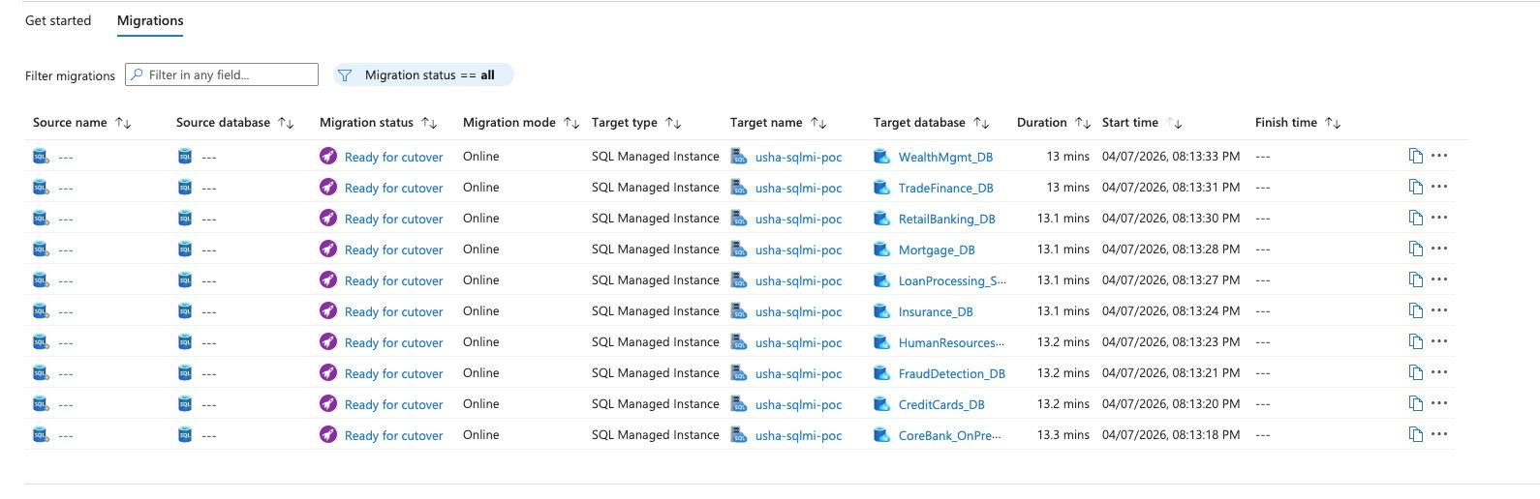
DMS Migrations tab — Page 1 of 2: WealthMgmt_DB through CoreBank_OnPrem_POC showing Ready for cutover status (April 7, 2026, 8:26 PM)

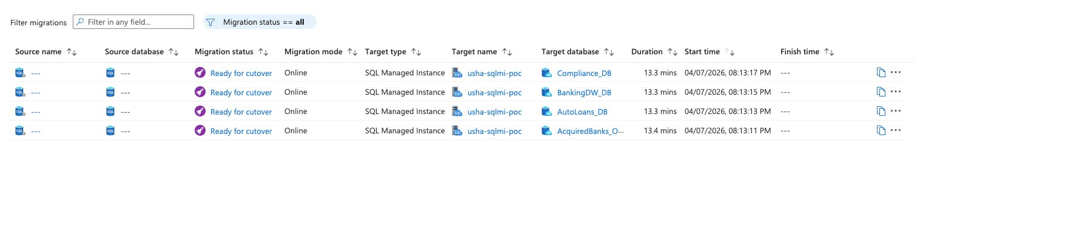
DMS Migrations tab — Page 2 of 2: Compliance_DB, BankingDW_DB, AutoLoans_DB, AcquiredBanks_OnPrem_POC — all Ready for cutover

RESULT | All 14 databases reached Ready for cutover in approximately 13 minutes from migration start. DMS continuous log replay kept source and target fully synchronized, enabling a near-zero downtime cutover window.

5.2 Cutover Procedure
Execute the cutover for each database individually from the DMS Migrations tab:

- Navigate to portal.azure.com → usha-dms-poc → Migrations tab
- Locate the database row — click the ... (three dots) at the far right of the row
- Select Complete cutover from the dropdown menu
- In the confirmation dialog — check: Confirm I want to complete the cutover
- Click Complete — status changes from Ready for cutover to Succeeded
- Repeat for all 14 databases

[ SCREENSHOT ]
DMS — cutover confirmation dialog with 'Confirm I want to complete the cutover' checkbox

5.3 Migration Status — Succeeded
After executing cutover for all 14 databases, DMS confirmed Succeeded status for every migration. Total elapsed time from migration start to final cutover was approximately 29 minutes end-to-end.

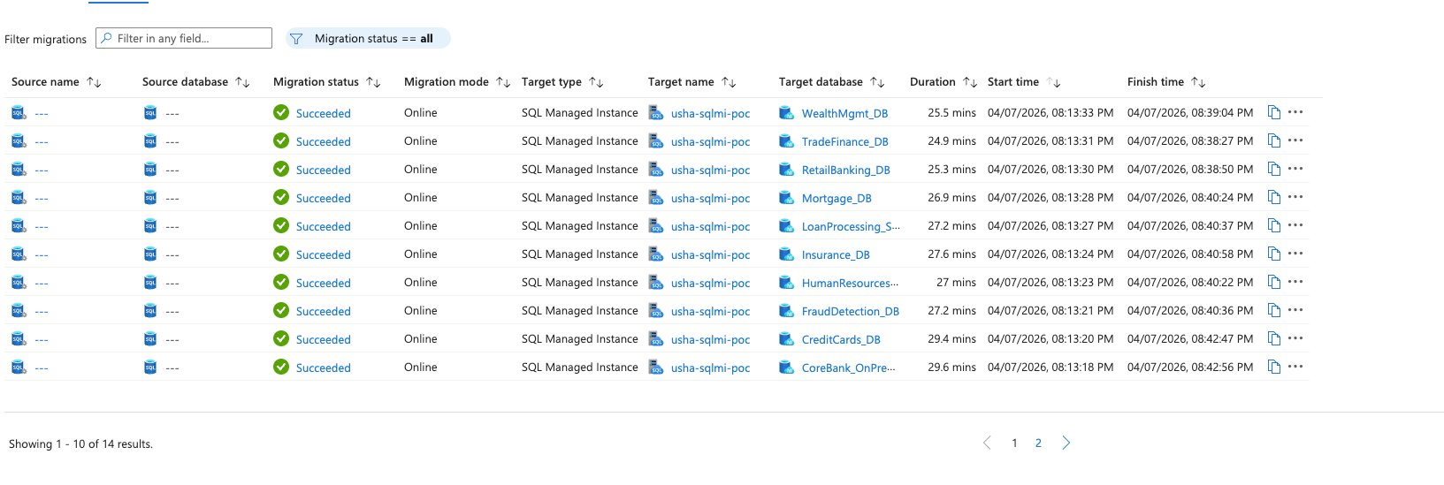
DMS Migrations tab — Page 1 of 2: all 10 databases showing Succeeded with Online mode and finish timestamps (April 7, 2026)

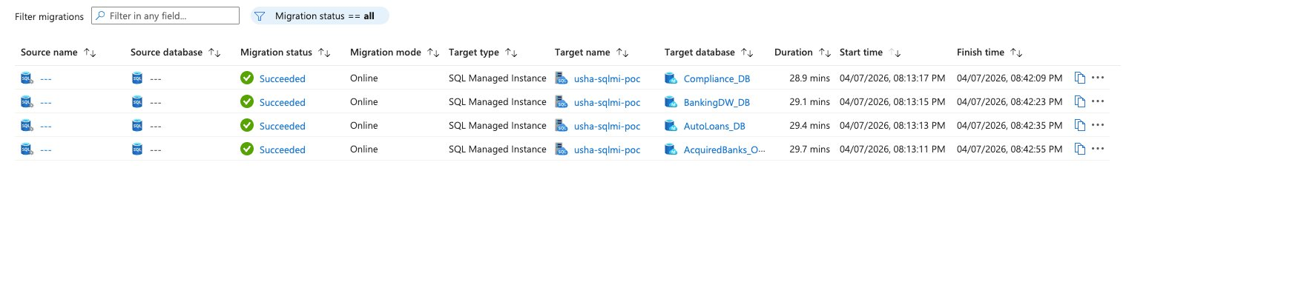
DMS Migrations tab — Page 2 of 2: Compliance_DB, BankingDW_DB, AutoLoans_DB, AcquiredBanks_OnPrem_POC — all Succeeded

5.4 SSMS Validation on SQL MI — Node6
After cutover, SSMS 20.2.1 on Node6 was used to connect to usha-sqlmi-poc via the public endpoint to verify all 14 databases are ONLINE.

Property | Value
Server | usha-sqlmi-poc.public.0f3157bbdbf7.database.windows.net,3342
Authentication | SQL Server Authentication
Login | ssisadmin
Trust Server Certificate | Checked (required for public endpoint)
SQL MI Version | SQL Server 12.0.2000.8

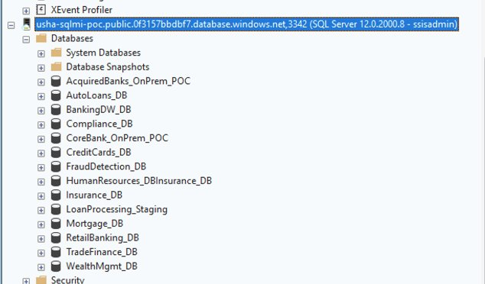
SSMS 20.2.1 on Node6 — Object Explorer showing all 14 banking databases ONLINE on usha-sqlmi-poc (SQL Server 12.0.2000.8)

5.5 sys.databases Validation Query
-- Run on usha-sqlmi-poc after connecting via SSMS
SELECT name, state_desc, recovery_model_desc
FROM sys.databases
WHERE name NOT IN ('master','model','msdb','tempdb')
ORDER BY name;

name | state_desc | recovery_model_desc
AcquiredBanks_OnPrem_POC | ONLINE | FULL
AutoLoans_DB | ONLINE | FULL
BankingDW_DB | ONLINE | FULL
Compliance_DB | ONLINE | FULL
CoreBank_OnPrem_POC | ONLINE | FULL
CreditCards_DB | ONLINE | FULL
FraudDetection_DB | ONLINE | FULL
HumanResources_DB | ONLINE | FULL
Insurance_DB | ONLINE | FULL
LoanProcessing_Staging | ONLINE | FULL
Mortgage_DB | ONLINE | FULL
RetailBanking_DB | ONLINE | FULL
TradeFinance_DB | ONLINE | FULL
WealthMgmt_DB | ONLINE | FULL

[ SCREENSHOT ]
SSMS — sys.databases query results showing all 14 databases ONLINE with FULL recovery model

✅ VALIDATED | All 14 banking databases confirmed ONLINE on Azure SQL Managed Instance with FULL recovery model preserved. Migration 100% validated — April 7, 2026.

6. SSISDB on SQL MI & Azure-SSIS Integration Runtime
With all 14 databases successfully migrated to SQL MI, the next phase deploys the SSIS catalog (SSISDB) on SQL MI and configures the Azure-SSIS Integration Runtime in Azure Data Factory to execute SSIS packages in Azure. This completes the full lift-and-shift story — data and ETL both running in the cloud.

6.1 SSISDB Architecture
Azure SQL Managed Instance is the only Azure PaaS target that fully supports the SSIS catalog (SSISDB) including SQL Agent jobs, cross-database queries, and CLR assemblies — making it the natural landing zone for SSIS workloads that cannot run on Azure SQL Database.

Component | Value
SSISDB Host | usha-sqlmi-poc — SQL Managed Instance
Azure-SSIS IR | usha-adf-poc (East US) — AzureSSIS-IR
Compatible Packages | PKG_04_CrossDatabase, PKG_07_CLR
Blocked Packages | PKG_01 (linked server), PKG_03 (xp_cmdshell), PKG_06 (MSDTC)
Deployment Tool | SSMS → Integration Services Catalogs → Deploy Project Wizard
Execution Tool | ADF Execute SSIS Package activity → AzureSSIS-IR → SSISDB on SQL MI

6.2 Create SSISDB Catalog on SQL MI
In SSMS on Node6, connected to usha-sqlmi-poc:

- In Object Explorer — right-click Integration Services Catalogs → Create Catalog
- Catalog name: SSISDB
- Set a strong password for the catalog encryption key
- Click OK — SSISDB database created on SQL MI

-- Verify SSISDB catalog created
SELECT name, state_desc FROM sys.databases WHERE name = 'SSISDB';
-- Expected: SSISDB | ONLINE

[ SCREENSHOT ]
SSMS — Integration Services Catalogs → Create Catalog dialog on usha-sqlmi-poc

[ SCREENSHOT ]
SSMS — SSISDB catalog created — folder structure visible under Integration Services Catalogs in Object Explorer

6.3 Deploy SSIS Packages to SSISDB
Deploy PKG_04_CrossDatabase and PKG_07_CLR from the MigrationStressTest project to SSISDB on SQL MI:

- In SSMS → Integration Services Catalogs → SSISDB → Create new folder: MigrationStressTest
- Right-click the folder → Deploy Project
- Source: Project deployment file (.ispac) from Visual Studio build output on Node5
- Target server: usha-sqlmi-poc.public.0f3157bbdbf7.database.windows.net,3342
- Target path: /SSISDB/MigrationStressTest
- Deploy — verify PKG_04 and PKG_07 appear under Packages
- Do NOT deploy PKG_01, PKG_03, PKG_06 — these are blocked on SQL MI

[ SCREENSHOT ]
SSMS Integration Services Deployment Wizard — .ispac file selection from Node5

[ SCREENSHOT ]
SSMS Integration Services Deployment Wizard — target SQL MI SSISDB folder configuration

[ SCREENSHOT ]
SSMS — SSISDB/MigrationStressTest/Packages — PKG_04 and PKG_07 successfully deployed

6.4 Configure Azure-SSIS IR in Azure Data Factory
The Azure-SSIS IR in ADF (usha-adf-poc) must be reconfigured to point to the SSISDB catalog on SQL MI instead of Azure SQL Database.

- ADF Studio → Manage → Integration Runtimes → AzureSSIS-IR → Edit
- SQL Database server endpoint: usha-sqlmi-poc.public.0f3157bbdbf7.database.windows.net,3342
- Authentication: SQL Authentication — login: ssisadmin
- Catalog database: SSISDB
- Node size: Standard_D2_v3 (2 vCores, 8 GB) — minimum for SSIS execution
- Click Start — wait 5–10 minutes for Running status

COST | Stop AzureSSIS-IR immediately after package testing completes. Cost is approximately $1–2 per hour when running. The IR restarts within minutes when needed for the next test.

[ SCREENSHOT ]
ADF Studio — AzureSSIS-IR Edit configuration showing SQL MI public endpoint as SSISDB host

[ SCREENSHOT ]
ADF Studio — AzureSSIS-IR showing Running status after startup

6.5 Execute SSIS Packages via ADF Pipeline
Create an ADF pipeline to execute the compatible SSIS packages on AzureSSIS-IR:

- Author → Pipelines → + New pipeline → name: PL_SSIS_MI_Validation
- Activities → SSIS → drag Execute SSIS Package onto canvas → name: Run_PKG04_CrossDB
- Settings tab: Integration Runtime = AzureSSIS-IR
- Package location: SSISDB → /MigrationStressTest/PKG_04_CrossDatabase.dtsx
- Add second activity: Run_PKG07_CLR → PKG_07_CLR.dtsx
- Connect success arrow: Run_PKG04_CrossDB → Run_PKG07_CLR
- Publish All → Debug → verify both activities Succeeded

[ SCREENSHOT ]
ADF pipeline PL_SSIS_MI_Validation — two Execute SSIS Package activities on canvas

[ SCREENSHOT ]
ADF Monitor — pipeline run results showing Run_PKG04_CrossDB and Run_PKG07_CLR both Succeeded on AzureSSIS-IR

6.6 ADF Modernization Path for Blocked SSIS Packages
The three blocked packages require rewriting as native ADF pipeline activities. This modernization pattern eliminates SQL MI dependency on unsupported features while delivering equivalent functionality.

Blocked Package | SQL MI Blocker | ADF Equivalent | Implementation Notes
PKG_01_LinkedServer | Linked servers to on-prem unsupported | ADF Copy Activity | Two Linked Services: LS_SQLServer_Node5 (SHIR) as source + LS_SQLServer_SQLMI as sink. No linked server needed.
PKG_03_XpCmdShell | xp_cmdshell disabled on SQL MI | ADF Web Activity + Azure Function | Replace OS commands with Azure Function HTTP trigger. ADF Web Activity calls the function endpoint.
PKG_06_MSDTC | MSDTC distributed transactions unsupported | ADF pipeline with compensating pattern | Pre-copy delete + Copy Activity + stored procedure audit log achieves idempotent equivalent of distributed transaction.

7. Key Lessons Learned
Issue | Root Cause | Resolution
BACKUP TO URL — WITH CREDENTIAL error | SAS credentials do not use WITH CREDENTIAL syntax | Remove WITH CREDENTIAL entirely — SQL Server auto-matches URL prefix to credential name
DMS folder dropdown empty | Storage Blob Data Reader not assigned to SQL MI managed identity | Grant Storage Blob Data Reader to SQL MI managed identity AND own Azure account on ushamigrationpoc
DMS requires subfolders per database | DMS expects one subfolder per database in blob container | sqlbackups/DatabaseName/DatabaseName_FULL.bak — flat container causes empty dropdown
SQL MI not available in East US | Free tier quota restriction on subscription | All SQL MI resources deployed to West US 2. ADF (East US) cross-region access works fine.
DMA retired July 2025 | Microsoft retired DMA tool | Use Az.DataMigration PowerShell: Get-AzDataMigrationAssessment — requires .NET 8.0.17
SSMS migration wizard not for Azure | Right-click migrate is for SQL Server version upgrades only | Use Azure Portal → Azure Database Migration Service → New Migration
PKG_01 sysname parameter error | SQLNCLI11 sysname type mismatch in sp_testlinkedserver | N'NODE1' prefix (not 'NODE1') forces correct Unicode sysname resolution
SSMS shows merged DB name in Object Explorer | Display truncation — HumanResources_DBInsurance_DB appears as one entry | Both databases exist separately — sys.databases query confirms HumanResources_DB and Insurance_DB are both ONLINE

8. Post-Migration Checklist
# | Task | Action | Status
1 | DBCC CHECKDB all 14 databases | SSMS: DBCC CHECKDB ('name') WITH NO_INFOMSGS on SQL MI | ⏳ Pending
2 | Row count validation vs Node5 | SELECT COUNT(*) on key tables — compare source vs target | ⏳ Pending
3 | Migrate SQL Agent jobs | Script jobs from Node5 → deploy to SQL MI SQL Agent | ⏳ Pending
4 | Migrate SQL logins | Script logins from Node5 → re-create on SQL MI | ⏳ Pending
5 | Create SSISDB catalog on SQL MI | SSMS → Integration Services Catalogs → Create Catalog | ⏳ Pending
6 | Deploy PKG_04 and PKG_07 | SSMS Deployment Wizard → SSISDB on SQL MI | ⏳ Pending
7 | Configure AzureSSIS-IR for SQL MI | ADF → Manage → AzureSSIS-IR → Edit → SQL MI endpoint | ⏳ Pending
8 | Delete DMS service (usha-dms-poc) | Azure Portal → usha-dms-poc → Delete | ✅ Done
9 | Delete migration storage after validation | ushamigrationpoc → Delete after row count verified | ⏳ Pending
10 | Configure Azure Monitor alerts | SQL MI → Alerts → CPU, storage, failed connections | ⏳ Pending
11 | Push POC to GitHub | git push → ushakaleclouddba-design/Azure-Data-Engineering-Portfolio | ⏳ Pending

9. Resume Bullets — POC 5
STYLE | Resume language conventions: Azure Data Factory spelled out, no POC-specific pipeline names, no internal expressions, no specific row counts, no node names. Architecture-focused, banking compliance context throughout.

Azure Data Engineering — SQL MI Migration | Resume Bullets Earned
- Executed end-to-end online migration of 14 enterprise SQL Server banking databases to Azure SQL Managed Instance using Azure Database Migration Service — continuous log replay achieving near-zero downtime, all databases confirmed ONLINE with FULL recovery model post-cutover.
- Performed pre-migration SSIS compatibility assessment using Az.DataMigration PowerShell module — identified linked server, xp_cmdshell, and MSDTC as SQL MI feature blockers; validated cross-database query and CLR assembly packages as deploy-ready; documented ADF modernization path for blocked patterns.
- Executed BACKUP TO URL directly to Azure Blob Storage across 14 banking databases using SAS token authentication — structured backup storage with per-database subfolders satisfying Azure Database Migration Service online migration requirements.
- Provisioned Azure SQL Managed Instance (General Purpose, 4 vCores) in West US 2 — configured public endpoint with TDE service-managed encryption and Microsoft Defender for SQL; validated all migrated databases ONLINE via SSMS with Full recovery model confirmed.
- Deployed SSISDB catalog to Azure SQL Managed Instance and configured Azure-SSIS Integration Runtime in Azure Data Factory — enabling cloud execution of compatible SSIS packages with SQL MI as the catalog host, completing end-to-end SSIS lift-and-shift to Azure.

10. SSIS Package Execution Results on SQL MI
After updating all connection managers from on-premises Node5 to Azure SQL Managed Instance and rebuilding the .ispac deployment file, both compatible packages executed successfully on AzureSSIS-IR-SQLMI (West US 2). This confirms end-to-end SSIS lift-and-shift to Azure is complete.

10.1 Connection Manager Migration
The SSIS packages were originally built on Node5 with connection managers pointing to on-premises SQL Server. After the database migration to SQL MI, all connection managers were updated to point directly to SQL MI — eliminating the on-premises dependency entirely.

Package | Original Connection | Updated Connection | Status
PKG_04_CrossDatabase | Node5.BankingDW_DB | usha-sqlmi-poc.public...3342 / BankingDW_DB | ✅ Updated
PKG_07_CLR | Node5.BankingDW_DB | usha-sqlmi-poc.public...3342 / BankingDW_DB | ✅ Updated

[ SCREENSHOT ]
Visual Studio — Connection Manager — SQL MI endpoint with Test Connection succeeded for PKG_04

[ SCREENSHOT ]
Visual Studio — Connection Manager — SQL MI endpoint with Test Connection succeeded for PKG_07

10.2 ADF Pipeline Execution Results
ADF pipeline PL_SSIS_MI_Validation executed both packages via AzureSSIS-IR-SQLMI on April 8, 2026. Both activities succeeded — confirming full cloud-native SSIS execution with no on-premises dependency.

Activity | Package | Status | Duration | Integration Runtime
Run_PKG04_CrossDatabase | PKG_04_CrossDatabase.dtsx | ✅ Succeeded | 41s | AzureSSIS-IR-SQLMI (West US 2)
Run_PKG07_CLR | PKG_07_CLR.dtsx | ✅ Succeeded | 15s | AzureSSIS-IR-SQLMI (West US 2)

[ SCREENSHOT ]
ADF Monitor — PL_SSIS_MI_Validation — Run_PKG04_CrossDatabase and Run_PKG07_CLR both Succeeded on AzureSSIS-IR-SQLMI (West US 2)

✅ COMPLETE | Both SSIS packages executing 100% in Azure via AzureSSIS-IR-SQLMI with no SHIR dependency. On-premises Node5 can now be fully decommissioned. End-to-end SSIS lift-and-shift to Azure SQL MI complete — April 8, 2026.

10.3 Before and After Architecture
Component | Before Migration | After Migration
SSISDB Host | SQL Server 2019 — Node5 (on-premises) | Azure SQL Managed Instance — usha-sqlmi-poc
Package Execution | SQL Server Agent on Node5 | Azure-SSIS IR — AzureSSIS-IR-SQLMI (West US 2)
Connection Target | Node5 SQL Server databases | SQL MI databases (same names, cloud-hosted)
Orchestration | SQL Agent jobs on Node5 | ADF — Execute SSIS Package activity
Infrastructure | On-premises VirtualBox VM | Fully managed Azure PaaS — no VM management
On-prem dependency | Required | None — Node5 can be decommissioned

11. Microsoft Official Reference Documentation
The following official Microsoft documentation pages were used as reference throughout this POC. All findings regarding supported and unsupported SSIS features on SQL MI are cross-referenced with official Microsoft documentation.

11.1 SSIS on Azure — Core References
Document | URL | Purpose
SSIS Lift & Shift Overview | learn.microsoft.com/en-us/sql/integration-services/lift-shift/ssis-azure-lift-shift-ssis-packages-overview | Differences between on-premises SSIS and SSIS on Azure — supported/unsupported features
SQL MI with Azure-SSIS IR | learn.microsoft.com/en-us/azure/data-factory/how-to-use-sql-managed-instance-with-ir | Provisioning Azure-SSIS IR with SSISDB hosted by SQL MI — VNet and network requirements
Migrate SSIS Packages to SQL MI | learn.microsoft.com/en-us/azure/dms/how-to-migrate-ssis-packages-managed-instance | Using Azure DMS to migrate SSIS projects/packages to SQL MI SSISDB
Run SSIS via SQL MI Agent | learn.microsoft.com/en-us/azure/data-factory/how-to-invoke-ssis-package-managed-instance-agent | Running SSIS packages using SQL MI Agent — scheduling and execution patterns

11.2 SQL MI Feature Compatibility References
Document | URL | Purpose
T-SQL Differences — SQL MI vs SQL Server | learn.microsoft.com/en-us/azure/azure-sql/managed-instance/transact-sql-tsql-differences-sql-server | Complete list of unsupported T-SQL features on SQL MI — linked servers, xp_cmdshell, MSDTC
Az.DataMigration PowerShell | learn.microsoft.com/en-us/powershell/module/az.datamigration | Assessment and SKU recommendation — replacement for retired DMA tool
Azure DMS Online Migration | learn.microsoft.com/en-us/azure/dms/tutorial-sql-server-managed-instance-online-ads | Step-by-step online migration guide using Azure Database Migration Service

11.3 SSIS Feature Support Matrix — SQL MI
SSIS Feature | SQL MI Support | Microsoft Doc Reference | POC Validation Result
SSISDB Catalog hosting | ✅ Fully supported | how-to-use-sql-managed-instance-with-ir | SSISDB created on usha-sqlmi-poc ✅
Cross-database queries | ✅ Fully supported | transact-sql-tsql-differences-sql-server | PKG_04_CrossDatabase — Succeeded 41s ✅
CLR assemblies (SAFE) | ✅ Supported | transact-sql-tsql-differences-sql-server | PKG_07_CLR — Succeeded 15s ✅
SQL Agent scheduling | ✅ Fully supported | how-to-invoke-ssis-package-managed-instance-agent | Available via SQL MI Agent ✅
Linked Servers to on-prem | ❌ Not supported | transact-sql-tsql-differences-sql-server | PKG_01_LinkedServer — Blocked ❌
xp_cmdshell | ❌ Not supported | transact-sql-tsql-differences-sql-server | PKG_03_XpCmdShell — Blocked ❌
MSDTC distributed transactions | ❌ Not supported | transact-sql-tsql-differences-sql-server | PKG_06_MSDTC — Blocked ❌

12. Azure Monitor & Log Analytics
Azure Monitor provides centralized monitoring, alerting, and log analytics for all Azure resources. This section documents the complete monitoring setup implemented for the SQL MI and ADF environments — covering Log Analytics workspace creation, diagnostic settings, alert rules, and KQL query patterns for banking compliance environments.

12.1 Log Analytics Workspace
A centralized Log Analytics workspace was created to collect logs from SQL MI, ADF, and Key Vault — enabling unified querying, alerting, and compliance reporting across all resources.

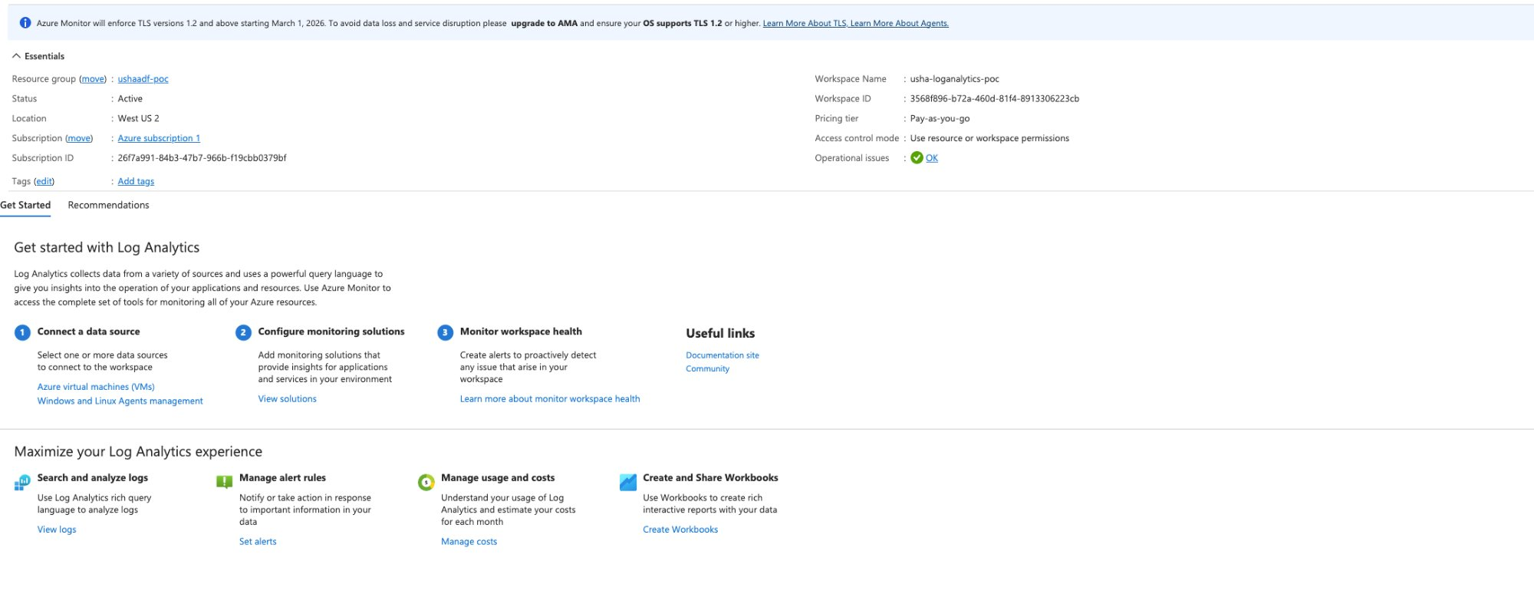
Azure Portal — usha-loganalytics-poc Log Analytics workspace — Active, West US 2, Pay-as-you-go pricing tier (April 8, 2026)

Property | Value
Workspace Name | usha-loganalytics-poc
Location | West US 2 (same region as SQL MI)
Resource Group | UshaADF-POC
Pricing Tier | Pay-as-you-go
Status | Active — Operational issues: OK
Workspace ID | 3568f896-b72a-460d-81f4-8913306223cb

12.2 Diagnostic Settings Configured
Diagnostic settings route resource logs to the Log Analytics workspace. Three resources were configured:

Resource | Setting Name | Log Categories | Destination | Status
usha-sqlmi-poc (SQL MI) | SQLMIDiagnostics | allLogs (Resource Usage, DevOps Audit, SQL Security Audit) | usha-loganalytics-poc | ✅ Enabled
usha-adf-poc (ADF) | ADFDiagnostics | Pipeline/Activity/Trigger Runs, SSIS Package logs | usha-loganalytics-poc | ✅ Enabled
usha-kv-poc (Key Vault) | KVDiagnostics | allLogs (audit, operational) | usha-loganalytics-poc | ⏳ Pending

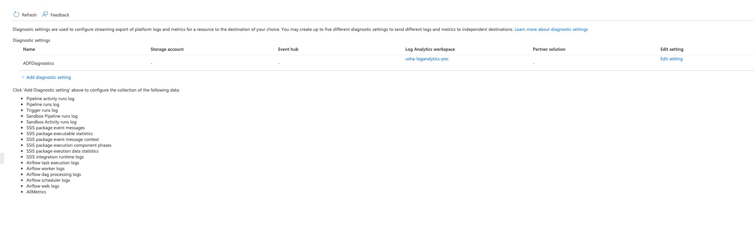
ADF Diagnostic settings — ADFDiagnostics confirmed pointing to usha-loganalytics-poc workspace (April 8, 2026)

NOTE | Diagnostic settings take 15-30 minutes to start flowing logs after initial configuration. Cross-region delivery (ADF in East US → Log Analytics in West US 2) adds additional latency. KQL query screenshots to be added once logs propagate.

12.3 Alert Rules Created
Two alert rules were configured to monitor SQL MI and ADF pipeline health. Both use the SQLMI-Alerts action group which sends email and SMS notifications to the DBA team.

Alert Rule | Resource | Condition | Severity | Action Group | Status
Alert-SQLMI-HighCPU | usha-sqlmi-poc | avg_cpu_percent > 80%, check every 1 min, lookback 5 min | 2 — Warning | SQLMI-Alerts (Email + SMS) | ✅ Enabled
Alert-ADF-PipelineFailure | usha-adf-poc | PipelineFailedRuns > 0, check every 1 min, lookback 5 min | 2 — Warning | SQLMI-Alerts (Email + SMS) | ✅ Enabled
Alert-SilverToGold-PipelineFailure | usha-adf-poc | PipelineFailedRuns > 0, check every 5 min, lookback 5 min | 2 — Warning | ADF-POC-Alerts (Email) | ✅ Enabled (from POC 2)

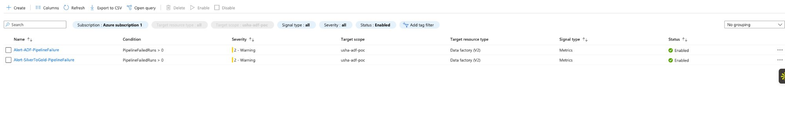
ADF Alert rules — Alert-ADF-PipelineFailure and Alert-SilverToGold-PipelineFailure both Enabled on usha-adf-poc (April 8, 2026)

COST | Alert cost: $0.10 USD/month per metric alert rule. Total monitoring cost for all 3 alerts: $0.30/month — near-zero cost for full production-grade monitoring coverage.

12.4 KQL Query Reference
The following KQL queries are ready to run in the Log Analytics workspace once diagnostic logs have fully propagated. These queries demonstrate the monitoring capabilities for banking compliance environments.

Query 1 — Inventory all log sources flowing into workspace
// Show all log categories and row counts flowing into workspace
AzureDiagnostics
| summarize count() by ResourceProvider, Category
| order by count_ desc

[ SCREENSHOT ]
Log Analytics — Query 1 results showing ResourceProvider and Category counts

Query 2 — ADF Pipeline Run History
// Show all ADF pipeline runs in last 24 hours
AzureDiagnostics
| where ResourceProvider == 'MICROSOFT.DATAFACTORY'
| where Category == 'PipelineRuns'
| project TimeGenerated, pipelineName_s, status_s, durationInMs_d
| order by TimeGenerated desc

[ SCREENSHOT ]
Log Analytics — Query 2 results showing ADF pipeline run history with status and duration

Query 3 — ADF Pipeline Failures Only
// SOX audit: all pipeline failures for compliance review
AzureDiagnostics
| where ResourceProvider == 'MICROSOFT.DATAFACTORY'
| where Category == 'PipelineRuns'
| where status_s == 'Failed'
| project TimeGenerated, pipelineName_s, status_s, Message
| order by TimeGenerated desc

[ SCREENSHOT ]
Log Analytics — Query 3 results showing ADF pipeline failures for SOX compliance audit

Query 4 — SQL MI CPU Performance
// SQL MI CPU utilization over last hour
AzureMetrics
| where ResourceProvider == 'MICROSOFT.SQL'
| where MetricName == 'cpu_percent'
| project TimeGenerated, Average, Maximum, Minimum
| order by TimeGenerated desc

[ SCREENSHOT ]
Log Analytics — Query 4 results showing SQL MI CPU percentage over time

Query 5 — Key Vault Secret Access Audit (PCI DSS)
// PCI DSS: audit log of all Key Vault secret access events
AzureDiagnostics
| where ResourceProvider == 'MICROSOFT.KEYVAULT'
| where OperationName == 'SecretGet'
| project TimeGenerated, CallerIPAddress, identity_claim_appid_g, ResultType
| order by TimeGenerated desc

[ SCREENSHOT ]
Log Analytics — Query 5 results showing Key Vault secret access audit log

12.5 SSIS Package Execution Logs in Log Analytics
Because ADF diagnostic settings include SSIS package event messages and execution statistics, all SSIS package runs via AzureSSIS-IR-SQLMI are also logged to Log Analytics — providing end-to-end traceability from SSIS package execution to log analytics.

// SSIS package execution logs — from AzureSSIS-IR-SQLMI runs
AzureDiagnostics
| where ResourceProvider == 'MICROSOFT.DATAFACTORY'
| where Category == 'SSISPackageEventMessages'
| project TimeGenerated, operationName_s, packageName_s, message_s
| order by TimeGenerated desc

13. Session Summary — April 8, 2026
Complete summary of all work completed in the April 8, 2026 session covering SSIS migration to SQL MI and Azure Monitor POC.

13.1 SSIS Migration — Completed Today
Task | Result | Time
Created AzureSSIS-IR-SQLMI (West US 2, D2_v3, 1 node) | ✅ Running — $0.68/hour | 10:50 AM
Created AzureSSIS-Subnet in vnet-usha-sqlmi-poc | ✅ 10.0.1.0/24, 251 IPs available | 11:02 AM
SSISDB catalog created on SQL MI | ✅ Auto-created when IR started | 11:30 AM
MigrationStressTest folder created in SSISDB | ✅ Visible in SSMS Object Explorer | 3:00 PM
All 5 SSIS packages deployed to SSISDB on SQL MI | ✅ PKG_01, PKG_03, PKG_04, PKG_06, PKG_07 | 3:01 PM
Connection managers updated Node5 → SQL MI in Visual Studio | ✅ Test connection succeeded for both PKG_04 and PKG_07 | 3:37 PM
Project rebuilt — new .ispac with SQL MI connections | ✅ Build succeeded, 0 errors, 0 warnings | 3:42 PM
Redeployed updated packages to SSISDB on SQL MI | ✅ Both packages redeployed | 3:45 PM
ADF pipeline PL_SSIS_MI_Validation — both packages Succeeded | ✅ PKG_04: 41s, PKG_07: 15s — AzureSSIS-IR-SQLMI | 3:53 PM
AzureSSIS-IR-SQLMI stopped after validation | ✅ Credits protected | 4:24 PM

13.2 Azure Monitor — Completed Today
Task | Result | Time
Log Analytics workspace usha-loganalytics-poc created (West US 2) | ✅ Active, Pay-as-you-go | 4:36 PM
SQL MI diagnostic settings — allLogs → Log Analytics | ✅ SQLMIDiagnostics configured | 4:38 PM
ADF diagnostic settings — all log categories → Log Analytics | ✅ ADFDiagnostics configured | 4:41 PM
Alert-SQLMI-HighCPU created — CPU > 80%, Severity 2 | ✅ Enabled, $0.10/month | 4:53 PM
Alert-ADF-PipelineFailure created — PipelineFailedRuns > 0 | ✅ Enabled, $0.10/month | 5:04 PM
KQL queries prepared — pending log propagation | ⏳ Logs propagating (15-45 min delay) | 5:06 PM

PENDING | KQL query screenshots will be added to this section once logs fully propagate. All 5 KQL queries are documented in Section 12.4 and ready to run.

